YSGOL UWCHRADD CAERGYBI
HOLYHEAD HIGH SCHOOL
Prifathro /Headteacher: Mr A. Rh. Williams

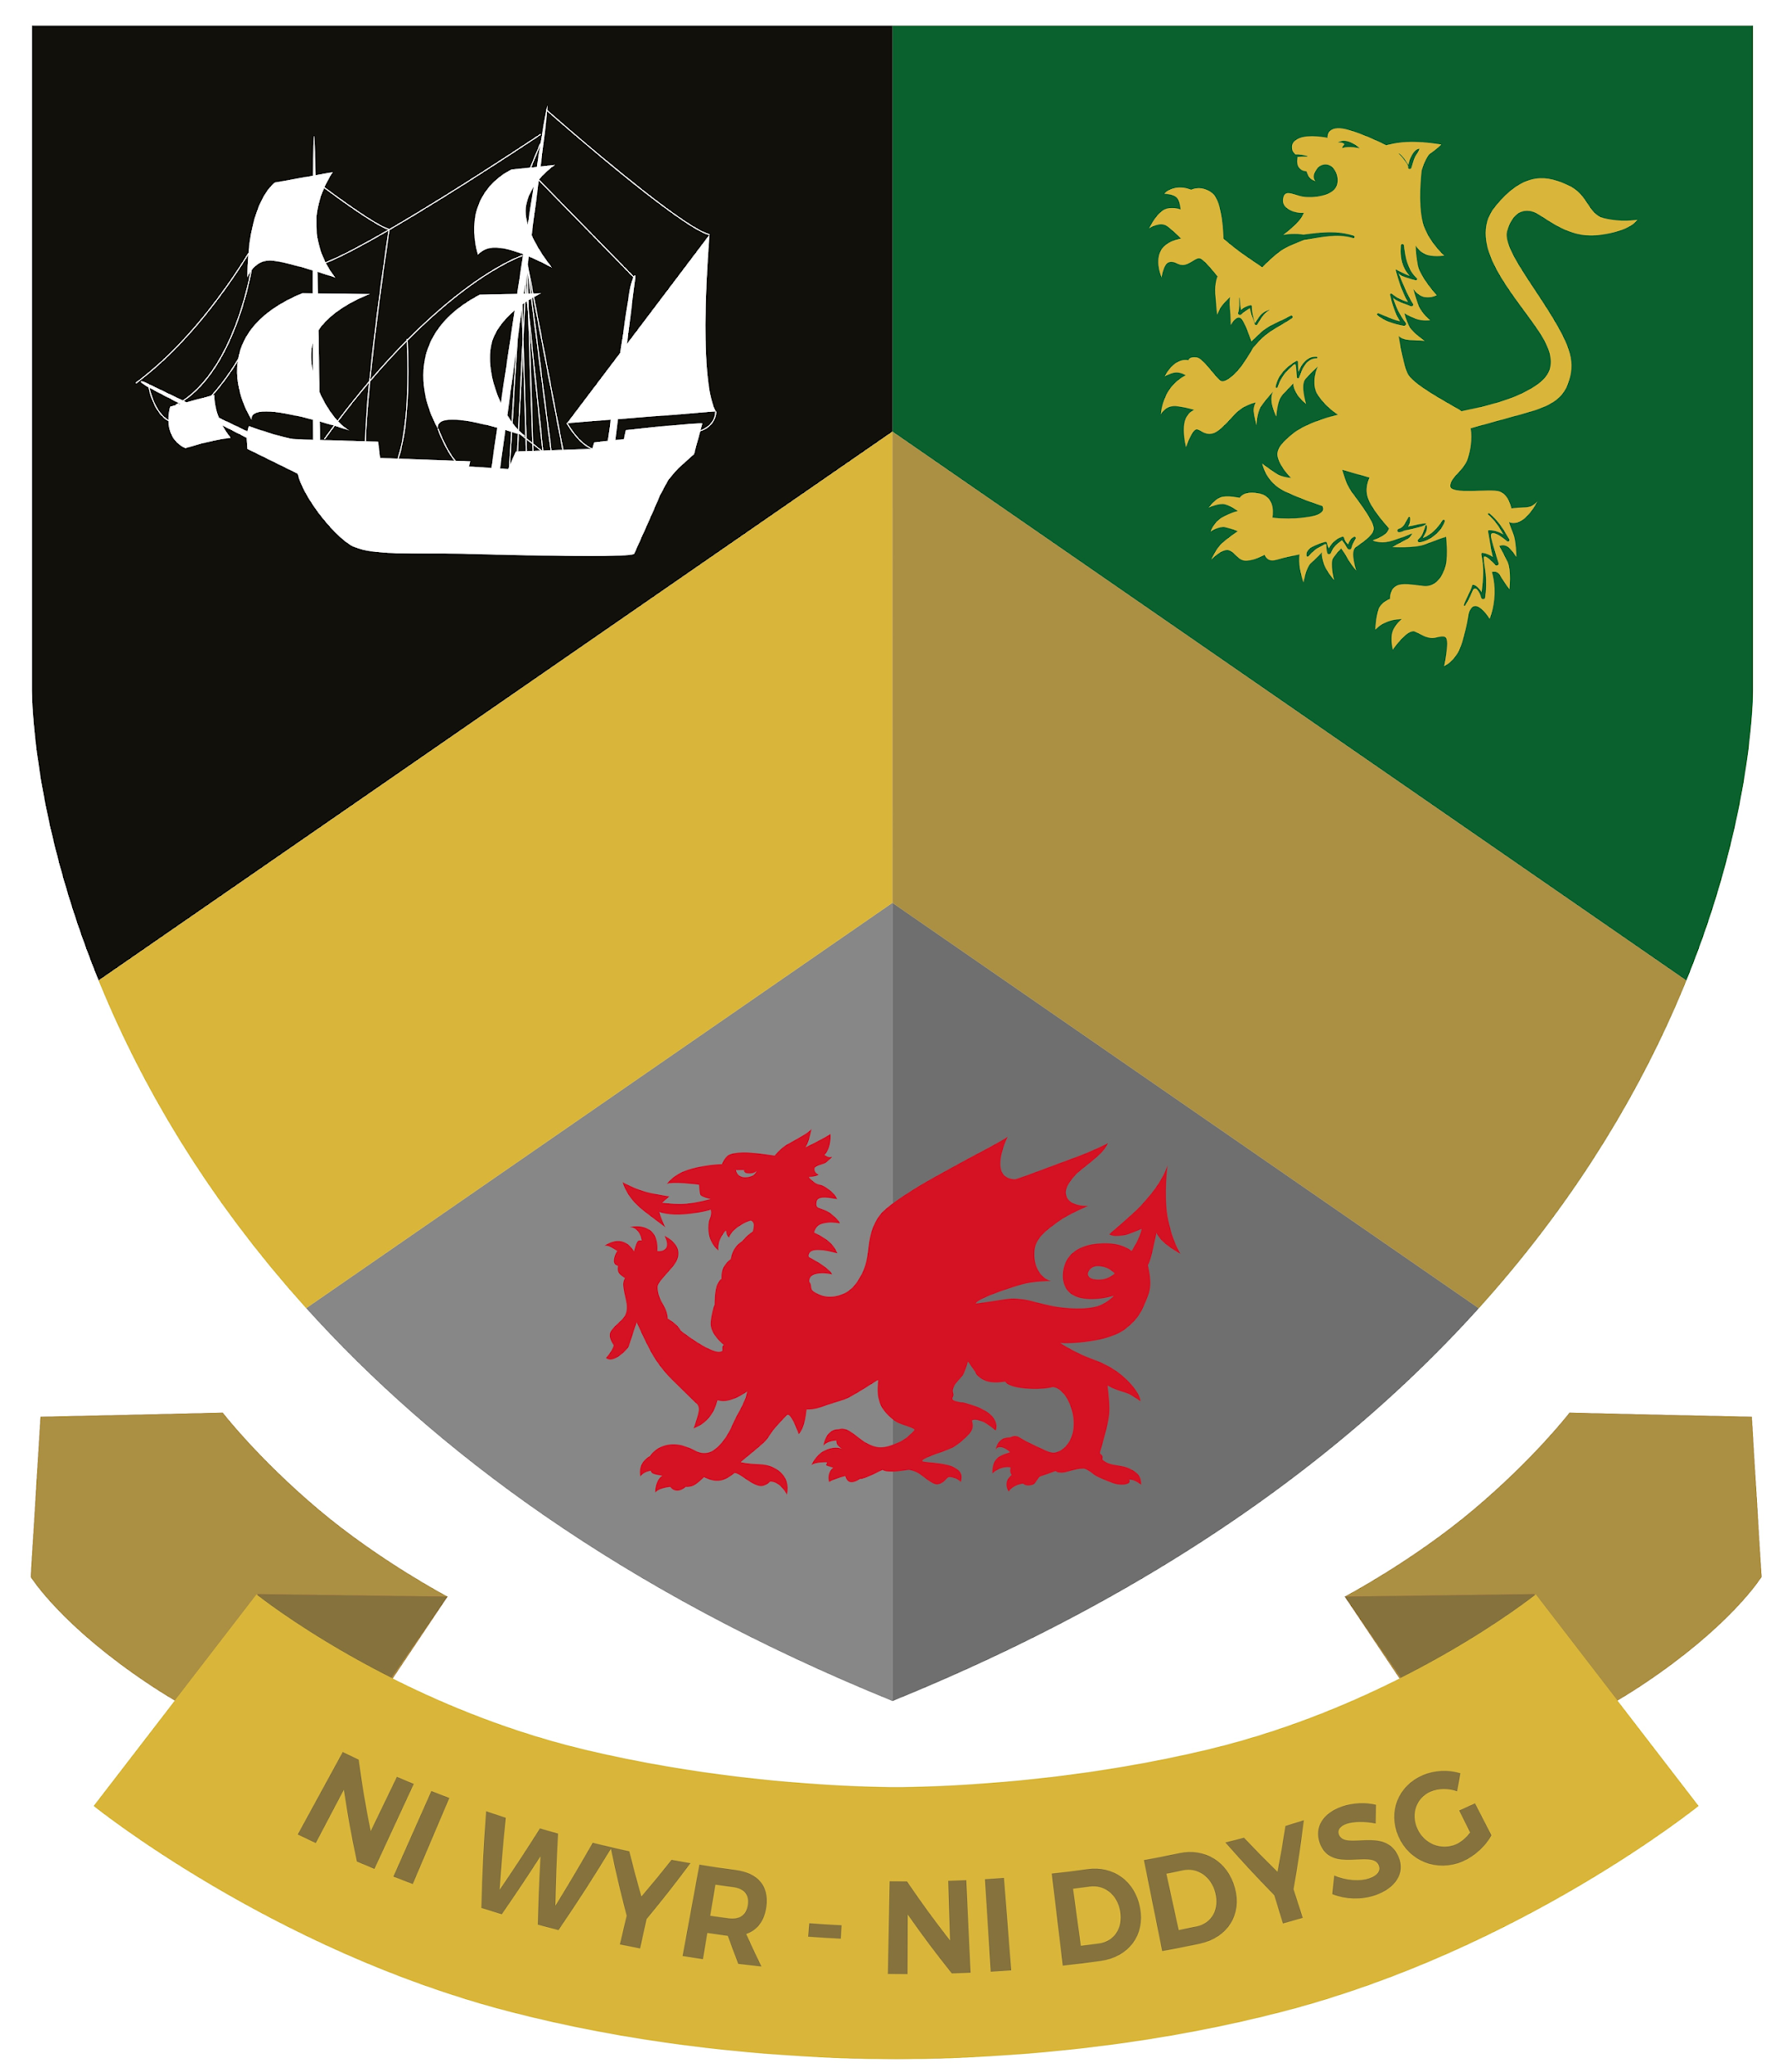
Isle of Anglesey
LL651NP
Tel: 01407 762219/763261
Pupil Absence Line: 01407764956

Ynys Môn
LL65 1NP
Ffôn: 01407 762219/763261
Llinell Absenoldeb Plentyn:
01407764956

CHROMEBOOK CONTRACT
Below is a contract agreement that must be read and accepted by the pupil and parent/guardian before a YUC Chromebook can be provided for the pupil. If the contract is not signed and returned to Ysgol Uwchradd Caergybi, a Chromebook will not be provided. It is important that each point outlined below is carefully considered and agreed to so that each person involved in this contract (the school, the pupil and the parent/guardian) are aware of what is expected of them.

THE CONTRACT

i) Both the pupil and parent/guardian must read the ‘Looking after your Chromebook to help it live longer!’ PowerPoint. This is available on the school website under the ‘Chromebooks 2021’ tab.
ii) The pupil must make every effort to maintain the Chromebook’s safety and care whilst it is in their possession.
iii) The pupil must report any damage or performance issues to the school as soon as it is evident to them.
iv) The YUC asset tag (green sticker on Chromebook) must not be removed or tampered with at any time.
v) The pupil must not consume food or liquids in close proximity of the Chromebook.
vi) The pupil cannot swap or exchange Chromebooks with other pupils at any time.
vii) The school can remove the Chromebook from the pupil at any time.
viii) The pupil must make every effort to bring their Chromebook to school daily, ensure it is charged and usable and take it home safely.

THE AGREEMENT

I agree to every point in the contract outlined above.

I agree to meet with the Progress Manager or member of Senior Leadership Team if my Chromebook is damaged as a result of lack of care, or damaged on purpose. This could result in the pupil or parent/guardian paying for costs incurred as a result.

Pupil …………………………………...…... Parent/Guardian ……………………………………...….

Date ………………………………………..

Regards,
Mr Adam Williams
Head Teacher

